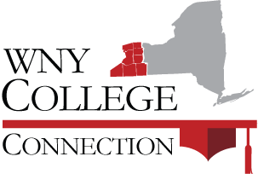

Veterans and Military Friendly Schools
Profile Page

School: Website:

Office/Department Name:

Veterans/Military School Contact Information:

Description (1 paragraph 3-5 sentences):

Student Veterans of America Chapter (y/n):

Recognition:

Scholarships:

Yellow Ribbon participant:

VA Work-Study Program:

Additional Information:

